**Assignment 2**

**Writing introductions**

**IELTS Writing Task 2:  Introductions**

**Remember:** When writing the introduction of IELTS essays there are **two steps** that need to be taken. **Paraphrase the task question and write a Thesis Statement**. If the question asks for an opinion, it must be in the **Thesis Statement**. It depends on the type of essay you are writing as they are not all the same. It is **necessary** to write a thesis in the introduction for every type of essay.

**A thesis statement** is logical and **shows the reader what to expect in the rest of the essay**.

**For each essay type this is what should be in the Thesis statement:**

1. **Opinion essays (agree/disagree):** write your opinion or how you feel about the topic.  
2. **Problem Solution essays:**  outline 1 or 2 problems and possible solutions.3**. Discussion essays:** after outlining both sides of the argument, give your opinion.  
4. **Two part question essays:** answer the 1st question then answer the 2nd question.

**First you have to identify what kind of essay it is.**

The first step before you begin to write is to make sure you understand the question, then identify what kind of essay this will be.

Before you write the thesis statement you will need to **paraphrase the question**.

**Example: Discussion essay question.**

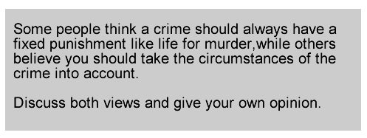  
Here you need to clearly outline both sides and then state your opinion.

This is **the Paraphrased introduction with a Thesis statement**.

**“A number of people believe serious crimes need to have a set punishment; others however feel the situation of the crime must be considered. I agree that the circumstances of the crime itself should be taken into account, because every case is different.’**

**Thesis/Position Statement:** ‘***I agree that the circumstances of the crime itself should be taken into account, because every case is different’***

**Follow the steps above and write an introduction for each question below:**

**1.**

***In many societies in the world, the population is ageing rapidly and this is leading to an unsustainable increase in the cost of public healthcare.***

***A nation’s population should pay for their healthcare provision in the future.***

***Do you agree or disagree with this statement.***

**Write your introduction (2 or 3 sentences) here:**

The global cost of public healthcare is rising unaffordably because of the rapidly aging population. Therefore, I agree that the nation’s residents should pay for healthcare insurance in case they become burdens to the country.

**2.**

***Some believe that people today have no interest in maintaining the traditional culture of their country or region. Others believe that it is still important to people that we preserve a traditional way of life.***

***Discuss both these views and give your own opinion.***

**Write your introduction (2 or 3 sentences) here:**

Whether to preserve a traditional way of life or not is always a controversial issue. In my opinion, maintaining a traditional way of life as a part of daily life is a better way to go since preserving a culture is a way to memorize the history as well.